DEHESA DE LUNA ROSÉ 2016
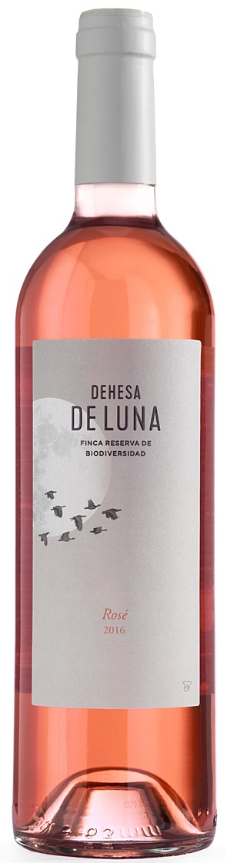 | Region: Vino de la tierra de  Castilla(Castilla la Mancha).  Grapes: 100% Cabernet Sauvignon  Vintage: 2016  Tasting Notes: a brilliant salmon colour. An intensely aromatic nose in which fruits like apples come to the fore, together with boxwood leaves hints. On the palate the wine is lively and unctuous with freshness and white flower flavours.  Food Pairings: Perfectly with rice or risotto type of dishes, Lasagna and any types of mushroom and seafood.

